**eBooks:**

How to access eBooks from your **school Library**:

* Log in to Clever.com
* Select **Follett Destiny eCatalog** (If you hover the cursor over the question mark(?); you will see your **user name** is you 6-digit ID and **password** is student)
* Log in to the catalog
* Click on **“Destiny Discover”** on the left
* Scroll to ebooks and click **“See All”**
* Click on the title you want (Most eBooks have **Read-Aloud** and **Translation** functions on top; highlight a word to get the **Dictionary** and **Note** functions)

How to access eBooks from the **public library:**

* Go to ypl.org
* Go to the **Technology tab** and select **eLibrary** from the drop-down menu
* Several companies provide eBooks to the YPL. Click on one to access such as:

**Overdrive/Libby OR Freading**

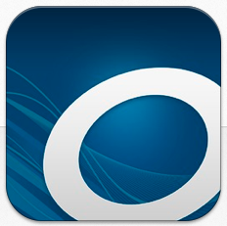 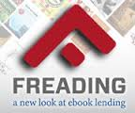

* You can browse titles (Overdrive will let you read the first 50 pages of a book without checking it out)
* You will need your library card to check out eBooks, audiobooks, or videos. You will need the bar code number on the back; your **PIN # is the last 4 digits of your phone number when you got your card.** You may have to contact the YPL to update your PIN # if your phone number has changed.